Install docker on EC2 and explore the docker commands (docker images, containers)

1) Installing the docker and docker compose in AWS-Mumbai-EC2-1

A: Installing docker

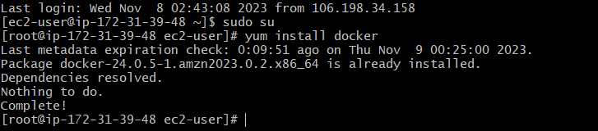

Checking the version of docker installed



Docker Commands

Create and run a new container from an image

Pull command to download the docker image

docker pull pengbai/docker-supermario

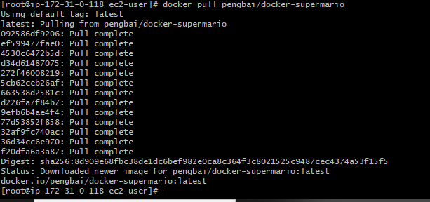

Command: docker run -itd -p 8690:8600 pengbai/docker-supermario



Execute a command in a running container

docker exec -it aa71

**Docker commands**

List containers

Docker ps

Docker ps -a 🡺 to list all containers



Docker kill 🡺 to remove a container

Docker stop 🡺 to stop a running container

Docker rm 🡺 remove one or more containers

Docker history 🡺 to show the history of an image

Docker -D 🡺 enable to debug